SPRING NEWSLETTER 2013

The Whole Dog Journal (a monthly guide to natural dog care and training)
Gave their verdict on NZ’s own ZiwiPeak air-dried canine diets, in one word: Awesome!

ZiwiPeak was compared with 5 other top freeze dried and dehydrated brands.
It notes ‘that because the moisture content of ZiwiPeak’s dried diets is higher than the other foods discussed and even higher than the moisture content of conventional kibble, it does not require rehydration.

ZiwiPeak is gently air-dried. It’s a slow process. But, as they say, good things take time. The process leaves a portion of natural moisture. It minimises damage to the proteins, vitamins and sensitive nutrients and enzymes in the all-natural ingredients.
Also they only use New Zealand sourced, human grade ingredients.

1 Portion of ZiwiPeak air-dried food = 3 Portions of raw meat.

So why do they add green lipped mussel to their diets? Because they contain high levels of glucosamine, chondroitin and omega 3 and 6. For optimal joint health.

Cost per day for a 10kg dog on Lamb cuisine (dry only) = $2.92

Cost per day for a 5kg cat on Venison cuisine (dry only) = $2.35
For more information visit www.ziwipeak.com

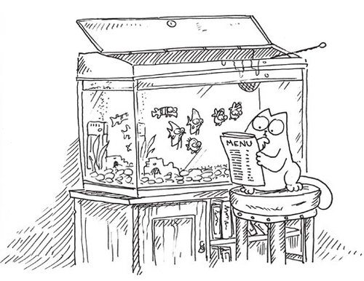

Did you know . . .
- Cats lose almost as much fluid in the saliva while grooming themselves as they do through urination.
- Cats lap liquid from the underside of their tongue, not from the top.
- Cats purr at the same frequency as an idling diesel engine, about 26 cycles per second.
- Contrary to popular belief, people are not allergic to cat fur, dander, saliva, or urine - they are allergic to "sebum," a fatty substance secreted by the cat's sebaceous glands. More interesting, someone who is allergic to one cat may not be allergic to another cat. Though there isn't (yet) a way of predicting which cat is more likely to cause allergic reactions, it has been proven that male cats shed much greater amounts of allergen than females. A neutered male, however, sheds much less than a non-neutered male.
- If your cat snores or rolls over on his back to expose his belly, it means he trusts you.
- Cats respond better to women than to men, probably due to the fact that women's voices have a higher pitch.

Natural disasters and unexpected events:
Due to the recent events of earth quakes and house fires I thought it was a good time to remind people to include pets in your family emergency plan.
Food and water while vital are not the only things required in your kit for your animals. Extra blankets and a spare collar and lead (for dogs) should also be added to your kit and always have your cat carry cages easily accessible.

You should also speak with your surrounding neighbours and let them know where your animals will be on a day to day basis. Especially those that are inside, and have no outside access and any animals in cages or kennels close to the house.

Let them know what you would like them to do in case they are home and you are not.
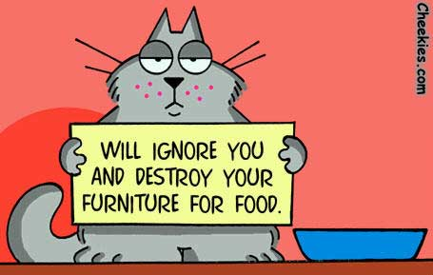
In the case of a fire, we recommend any animals in confinement should be released as soon as possible. Even if that means just opening all the doors and letting them run to safety. Never have a reason to go back.

